

Daddy Phol

@54



Happy 14th Birthday,

Clouie

# 



# 

Happy 16th Birthday,

Mary Nicole

# 

Happy 2nd Birthday

Happy Birthday,

Mommy Bhelou

Happy Fiesta!!!

Nuestra Sra.

del Rosario



Happy Fiesta!!!

Nuestra Sra.

del Rosario



Happy

Fiesta!

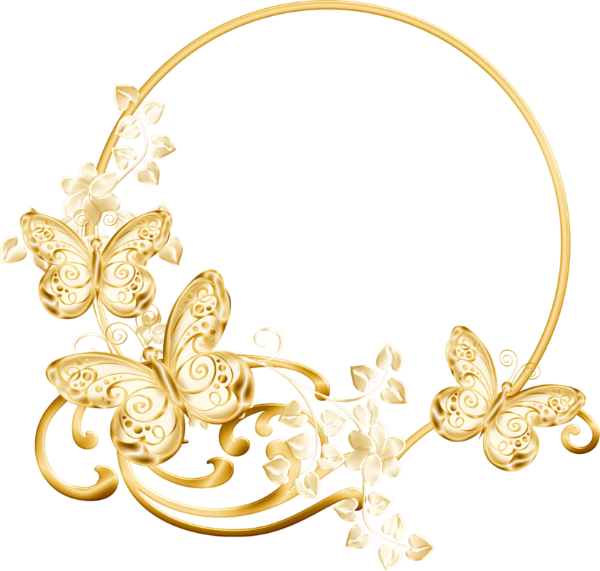

Happy 17th Birthday,

**Z** ylcee Love



Happy

Fiesta!



Happy Birthday,

Kathrina!

